**Chapter I : What is Fascism?**

<INTRODUCTION>

**Historical Fascism**

*Benito Mussolini & the Original Fascist Movement*

*“In the Fascist conception of history, man is man only by virtue of spiritual process to which he contributes as a member of the family, them as a social group, the nation, and in function of history to which all nations bring their contribution.”[1]1*

The original fascist movement, Mussolini's Fascist Party of Italy, emerged as a result of a combination of individual circumstances and social, economic and political factors leading up to and immediately following World War I. Fearing a proletariat uprising similar to the Bolshevik revolution which brought Joseph Stalin into power of the Soviet Union, unfavorable economic conditions as a result of war and a possessing a grave distrust of the current Italian government, led by Prime Minister Luigi Facta, many Italians – including Italian Catholics – were willing to take up arms and overthrow the perceived corruption of the time.

However, without the Italian Socialist Party revoking Benito Mussolini's membership as a result of his pro-war stance, Mussolini would have likely remained a lifelong socialist. “You cannot get rid of me because I am and always will be a socialist. You hate me because you still love me”, Mussolini exclaimed, post-expulsion from the Italian Socialist Party in 1914[2]2. Despite using the socialist party as a common enemy to unite the country against, the bulk of policy influence can be traced back to Mussolini's previous involvement in socialist movements.

Mussolini's early exposure to socialist policies influenced his later political views and actions as leader of the Fascist Party. In 1902, Mussolini emigrated to Switzerland to avoid compulsory military service in the Italian Royal Army. During his time in Switzerland, Mussolini became exposed to the philosophy of Friedrich Nietzsche and syndicalist Georges Sorel. Georges Sorel openly advocated for the use of violent force to overthrow liberal democracy and capitalism. Mussolini gradually became more and more actively involved in the socialist movement, working as a journalist for *L'Avveniore del Lavatore* and as a secretary for the Italian worker's union in Laussane. Gaining a reputation as being a problematic individual and potential revolutionary, Mussolini was arrested (Figure 1.1) for inciting political viollence during a general labor strike in Berne, Switzerland, and was subsequently reported back to Italy.

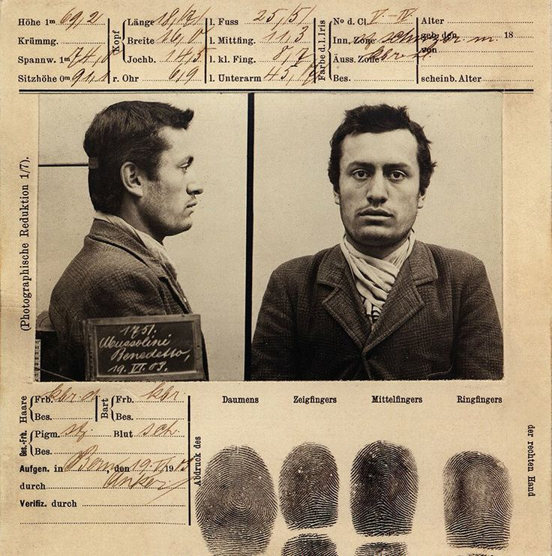

Figure 1.1 – Benito Mussolini's booking document from arrest.

Following deportation to Italy, Mussolini became active in the Italian socialist movement, working his way up the ranks in the Partito Socialista Italiano (PSI, or the Italian Socialist Party). He sought change through revolutionary, not political, action, as evidenced by his comment following a 1913 police shooting of seven protesting farmworkers, “Death to those who massacre the people! Long live the revolution!”[3]3 His involvement in PSI was relatively short-lived, as a result of his support for Socialist International (SI), a socialist and communist organization who supported violent insurrections and revolutionary action in general during the early twentieth century. The neutral stance of PSI was detrimental to Italy's own interests, per Mussolini, and was the beginning of his split from the socialists in the country.

After his split with PSI, Mussloni served in the Regio Esercito Italiano (Royal Italian Army) until 1917, when he suffered physical injury and was discharged unceremoniously. After serving in World War I and observing the detrimental effects of the war on the Italian economy and the morale of the Italian people, Mussolini shifted his focus away from pure socialism to a nationalism / socialism hybrid platform, created under the Partito Nazionale Fascista (National Fascist Party). NFP gained significant support from the military, business class, other right-wing aligned groups such as the conservative party. This spawned a militant group of revolutionaries, Milizia Volontaria per la Sicurezza Nazionale, more commonly known as the Squadristi or “Blackshirts”.

Gaining a majority following required making compromises, engaging in scare tactics and drafting a variety of truces. Mussolini attempted to create a truce with the PSI. Mussolini drafted the Pacification Pact, which was dissolved in less than a year, in November 1921. Even though he was unable to create an alliance with the Italian Socialist Party, the National Fascist Party continued to gain support, with approximately 700,000 members in July 1922[4]4. In August 1922, an anti-fascist movement attempted a general strike, but failed as a result of lack of support from the general population.

Even though Mussolini was unable to win over the majority of identified socialists in Italy, he utilized his persuasiveness on other important demographic groups within Italy. One key group was returning veterans, with hundreds of thousands of veterans returning from World War I unable to locate work[5]5. Mussolini identified issues with winning veterans over with communism and socialism, given the typical veteran's sense of camaraderie and strong national identity. Mussolini explained his socialist-influenced policies under the guise of nationalism to the veterans who felt abandoned after the war, given the inability of the Italian government to provide all of the necessary services and pensions due to financial collapse and the lack of readily available employment. The veterans provided the Fascist Party with a strong group of allies, both prior to the coup d'etat as well as in the early years of the regime.

The region where Italy resides is historically known for Rome, where the Vatican is located. Until 1870, the Pope was the authority over Rome and the surrounding area. However, with the unification of the kingdom of Italy, the Papal States lost control over a significant portion of previously held land. As a result, the papacy held a grudge against the Italian government. Prior to the 1921 election, the Catholic Popular Party, fighting against the upcoming Fascists, were able to gain parliamentary seats, up to 107, with the Fascists only being elected to 35 seats. The Conservatives constructed a coalition with the Fascist party to gain a parliamentary majority. When Parliament convened, Mussolini gave his first speech, where he discussed the importance of Rome being the spiritual home for hundreds of millions of Catholics throughout the world and his desire to restore a Christian society[6]6. Convincing the Pope to abandon the Catholic Popular Party and embrace the Fascist Party was essential to Mussolini's rise into power, as it provided him with a significant base to draw support. While seemingly an incompatible alliance – the Fascists and the Papacy – both Mussolini and the Catholic Church sought an ending of the liberal democratic regime, as well as a restoration of an orderly, authoritarian political structure.

1922 was the year of the Fascists rise to power and overthrow of the existing government. Pope Pius XI, the newly elected pope, was concerned about Mussolini and his National Fascist Party, especially given violence against Catholic Action, while simultaneously questioning whether it would be a good idea to directly oppose the Blackshirts. Witnessing the crushing defeats the socialists and other opposition groups experienced during the spring and summer of 1922, and while possessing a negative view of parliamentary government, Pope Pius XI refused to align himself with the Catholic Party, nor with any other political party initially, and Cardinal Gasparri, the Vatican Secretary of State, mailed out a circular to all Italian bishops advising political neutrality.

In October 1922, Mussolini and the Quadrumvirates, consisting of Emilio de Bono, Michele Bianchi, Italo Balbo and Cesare De Vecchi, proceeded with a plan for the National Fascist Party to siege control of Rome. A few days prior to the March on Rome, Mussolini contacted the United States Ambassador Richard Washburn Child, who provided encouragement to proceed with his plans. Led by the Quadrumvirs, the March on Rome proceeded, followed by the current leader, Prime Minister Luigi Facta, ordering a state of seige on Rome and requested assistance from King Victor Emannuel III. Under pressure from Mussolini and the National Fascist Party, King Emannuel III refused to sign Prime Minister Facta's military order and subsequently, on October 29th, 1922, the king granted Benito Mussolini the position of Prime Minister.

1. Quote by Benito Mussolini, from *The Doctrine of Fascism,* 1932.
2. Quote by Benito Mussolini, from Denis Mack Smith's *Mussolini: A Biography, 1983, pg. 8.*
3. Quote by Benito Mussolini. Cited in David Kertzer (2014)'s *The Pope & Mussolini.*
4. Statistic obtained from David Kertzer's *The Pope & the Dictator (2014), pg 24.*
5. David Kertzer's *The Pope and the Dictator*, page 25.
6. David Kertzer's *The Pope and the Dictator,* page 27.